**CDAC ATC NETCOM JAIPUR**

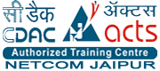

**Project: Online Rajasthan Tourism Website**



Submitted by: Guided by:

Arju Bano Mr Deependra

Shikha Tiwari

**Abstract**

This training on “Python with Django Framework” gave me a sound knowledge of Python and how websites, gui’s are developed using Python. This training focusses on the development of stable and efficient Python website development using Django Framework. Tkinters and PyQt5 was also a part of training which are GUI interface in puthon. During the training UI development was the main focus in which bootstrap, CSS, HTML, JSON, JavaScript was the important parts.

CDAC ATC NETCOM is well established and renowned for its summer training. Training module consist of industry oriented syllabus, which helps student to improve their technical skills. CDAC provide training on various new technologies and these training is given by industry experts. Training includes 3 hours / day, 5 days/week schedule. Every day a major topic of the android was covered, and every week a module has to be completed by the student. Every week training included a doubt session in which all the doubts are cleared by trainers.

A Yoga_Fit is a special type of application program which provide an intuitive and comprehensive Yoga lessons for everyone. Yoga_Fit will help many people get and stay healthier lifestyle. Yoga_Fit provide information about the upcoming events so that people can enroll themselves for these events. It will provide the proper diet plan for yogis and lead them towards a healthier life. Yoga is no longer simply a singular pursuit but a lifestyle choice. People come to Yoga and stick with it in order to live a healthier life. Yoga_Fit is a valuable therapeutic tool for many health condition. It provides yogasanas for different health conditions.

**Chapter 1**

**Introduction**

* 1. **Introduction to the Company**
     1. **Background of the Company**

Centre for Development of Advanced Computing (C-DAC) is the premier R&D organization of the Department of Electronics and Information Technology (DeitY), Ministry of Communications & Information Technology (MCIT) for carrying out R&D in IT, Electronics and associated areas. Different areas of C-DAC, had originated at different times, many of which came out as a result of identification of opportunities. While C-DAC was being setup for the indigenous design, development and delivery of the supercomputing technologies for the country, the mandate given was to not only develop the supercomputing technologies in the shortest possible time, but also continue to develop the high quality human resource, which will continue to develop such advanced technologies.

* + 1. **Company Profile Information**
       1. **Name :** C-DAC ATC NETCOM
       2. **Address :** Software IT Park IT-23, Sitapura Industrial Area, EPIP, Opposite RIICO Office, Near Globe Circle, Jaipur, Rajasthan 302022
       3. **Website :**www.netcomedu.in
       4. **Phone no :** 096492 72709
    2. **Technical Areas**

C-DAC has today emerged as a premier R&D organization in IT&E (Information Technologies and Electronics) in the country working on strengthening national technological capabilities in the context of global developments in the field and responding to change in the market need in selected foundation areas.  In that process, C-DAC represents a unique facet working in close junction with MeitY to realize nation’s policy and pragmatic interventions and initiatives in Information Technology.

* High Performance Computing Grid & Cloud Computing
* Multilingual Computing & Heritage Computing
* Software Technology Using FOSS
* Cyber Security & Cyber Forensics
* Education & Training
  + 1. **Nature of the Business**

NETCOM is authorized training centre of the C-DAC, which is known for its 100% placement records and high class training methods in state of art infrastructure. NETCOM is committed to deliver high class training with industry experts. With latest labs and practical approach of the training, students are getting placed in every area of IT domain. NETCOM is having its own Software Development Company “Net PARAM Technologies Pvt. Ltd.” which is completely involved in IT products and service delivery.

* 1. **Organizational Structure**

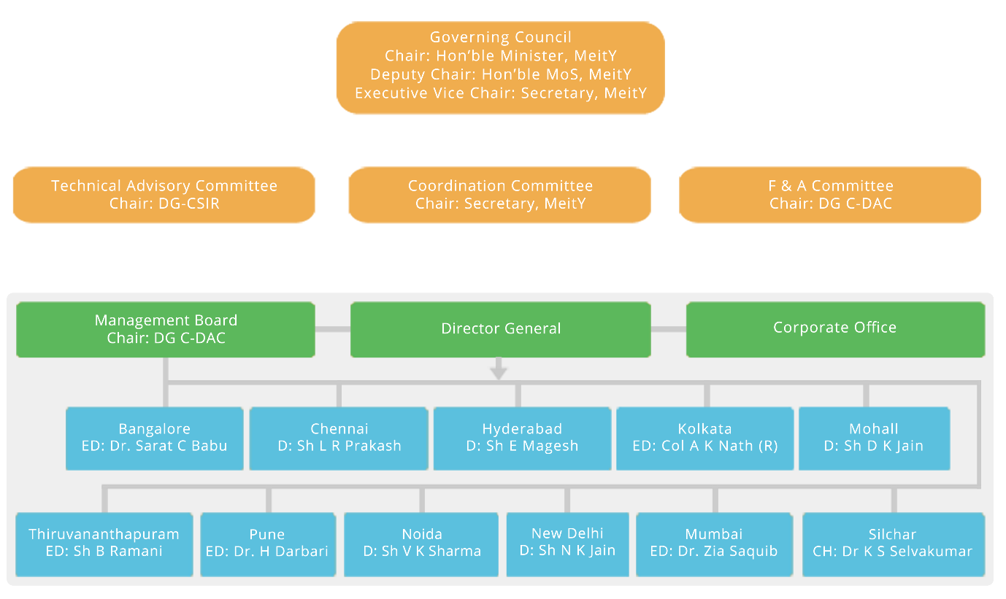

**Fig 1.1 Organizational Structure**

* 1. **Company Infrastructure**

NETCOM is equipped with the latest infrastructure which provides a congenial and a healthy learning environment to the students. It provides air-conditioned, interactive and well-furnished classrooms with audio visual aids of training. It has computer labs, library, seminar hall, workshops in campus. In Netcom, courses are taught by expert faculty who are trained, tested and certified to ensure that their knowledge is in step with latest industry trends. It mentors the students and develops the professional quality in them. It provides Placement assistance to the students through a Placement Support Program and helps to increase employability for students.

* 1. **Services Offered**

CDAC offer following services:

* High Performance Computing Grid & Cloud Computing
* Multilingual Computing & Heritage Computing
* Software Technology Using FOSS
* Cyber Security & Cyber Forensics
* Education & Training
  1. **Conclusion**

This part of the report provides us information about company, its infrastructure, and network and department structure.

**Chapter 2**

**Overview of the Training**

* 1. **Introduction to the training**

Python is a  [multi-paradigm programming language](https://en.wikipedia.org/wiki/Multi-paradigm_programming_language). [Object-oriented programming](https://en.wikipedia.org/wiki/Object-oriented_programming)  and [structured programming](https://en.wikipedia.org/wiki/Structured_programming) are fully supported, and many of its features support  [functional programming](https://en.wikipedia.org/wiki/Functional_programming) and [aspect-oriented programming](https://en.wikipedia.org/wiki/Aspect-oriented_programming) (including by  [meta programming](https://en.wikipedia.org/wiki/Metaprogramming) and [meta objects](https://en.wikipedia.org/wiki/Metaobject) (magic methods)).  Many other paradigms are supported via extensions, including [design by contract](https://en.wikipedia.org/wiki/Design_by_contract) and [logic programming](https://en.wikipedia.org/wiki/Logic_programming).

* 1. **Mode of Training**

Training included 3 hours per day 5 days a week mode in which a module has to be completed every week. Training was focussed on developing advance learning skills for android application development & its component. After completing every module, a doubt class was organized in which all the problems faced during development are solved.

**2.2.1. Training Schedule**

**Duration :** 3 hours/day 5 days/week

**Assignment :** On daily Basis

* 1. **Introduction to the syllabus module**

Python is a general-purpose interpreted, interactive, object-oriented, and high-level programming language. It was created by Guido van Rossum during 1985- 1990. Like Perl, Python source code is also available under the GNU General Public License (GPL).

Python is meant to be an easily readable language. Its formatting is visually uncluttered, and it often uses English keywords where other languages use punctuation. Unlike many other languages, it does not use [curly brackets](https://en.wikipedia.org/wiki/Curly_bracket_programming_language) to delimit blocks, and semicolons after statements are optional. It has fewer syntactic exceptions and special cases than [C](https://en.wikipedia.org/wiki/C_(programming_language)) or [Pascal](https://en.wikipedia.org/wiki/Pascal_(programming_language)).

* + 1. **Initial Stage of android**

Python is commonly used in [artificial intelligence](https://en.wikipedia.org/wiki/Artificial_intelligence) projects with the help of libraries like [TensorFlow](https://en.wikipedia.org/wiki/TensorFlow), [Keras](https://en.wikipedia.org/wiki/Keras) and [Scikit-learn](https://en.wikipedia.org/wiki/Scikit-learn). As a scripting language with [modular architecture](https://en.wikipedia.org/wiki/Modular_programming), simple syntax and rich text processing tools, Python is often used for [natural language processing](https://en.wikipedia.org/wiki/Natural_language_processing). Many operating systems include Python as a standard component. It ships with most [Linux distributions](https://en.wikipedia.org/wiki/Linux_distribution), [AmigaOS 4](https://en.wikipedia.org/wiki/AmigaOS_4), [FreeBSD](https://en.wikipedia.org/wiki/FreeBSD) (as a package), [NetBSD](https://en.wikipedia.org/wiki/NetBSD), [OpenBSD](https://en.wikipedia.org/wiki/OpenBSD) (as a package) and [macOS](https://en.wikipedia.org/wiki/MacOS) and can be used from the command line (terminal). Many Linux distributions use installers written in Python: [Ubuntu](https://en.wikipedia.org/wiki/Ubuntu_(operating_system)) uses the [Ubiquity](https://en.wikipedia.org/wiki/Ubiquity_(software)) installer, while [Red Hat Linux](https://en.wikipedia.org/wiki/Red_Hat_Linux) and [Fedora](https://en.wikipedia.org/wiki/Fedora_(operating_system)) use the [Anaconda](https://en.wikipedia.org/wiki/Anaconda_(installer)) installer. [Gentoo Linux](https://en.wikipedia.org/wiki/Gentoo_Linux) uses Python in its [package management system](https://en.wikipedia.org/wiki/Package_management_system), [Portage](https://en.wikipedia.org/wiki/Portage_(software)).Python is used extensively in the [information security](https://en.wikipedia.org/wiki/Information_security) industry, including in exploit development.

* + 1. **Architecture**

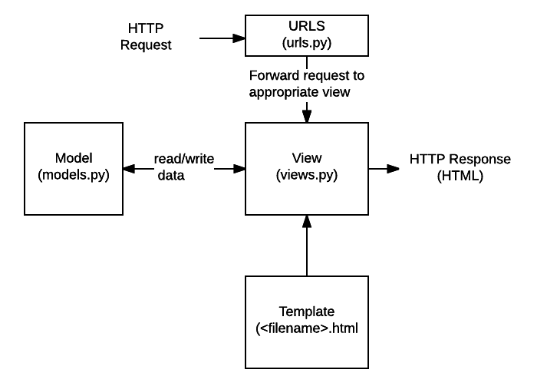

**Fig. 2.1 Django MVC Architecture**

**2.3.2.1 Django Framework**

Django is a high-level Python Web framework that encourages rapid development and clean, pragmatic design. Django is a free and open source web application framework written in Python. It is used to design the web page inside the Django Architecture. Django also supports AJAX(Asynchronus Java Script and XML), Jquery(for animation purpose), Bootstrap(for designing), JavaScript for validation purpose, etc. Django is MVC(Model-View-Controller) Architecture and also based on MVT(Model View and Template).

**2.3.2.2 Steps to create Django Project**

1. python-admin startproject project_name
2. cd project_name
3. python manage.py startapp app_name
4. python manage.py migrate
5. python manage.py createsuperuser
6. Enter username:
7. Enter email:
8. Enter password:
9. python manage.py runserver
10. python manage.py makemigrations
11. python manage.py migrate
12. open project in pycharm
    1. **Topics covered:**

* Classes, Objects, Loops, Exceptions.
* List, Tuples, Dictionary.
* Regular expressions.
* CGI programming.
* Socket programming.
* Multi threading.
* GUI programming.
* Network application Programming.
* PyQt5
  1. **Training Photos**

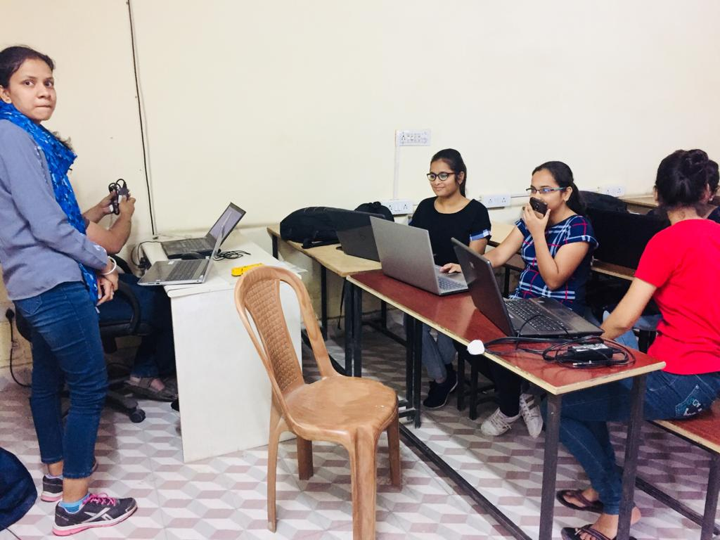

**Fig 2.2 Doubt session**

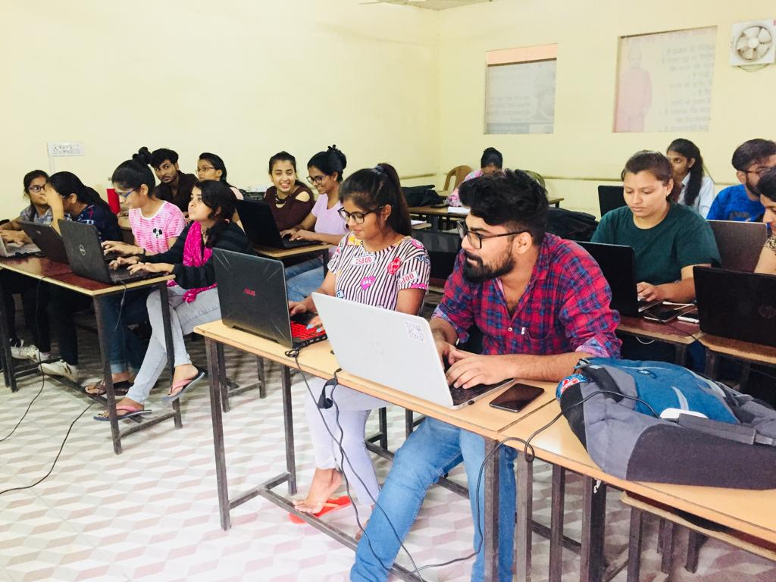

**Fig 2.3Coding session**

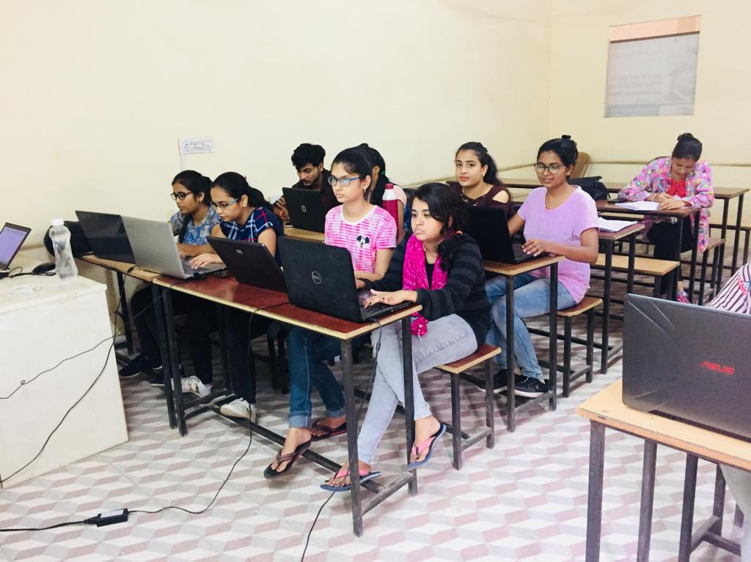

**Fig. 2.4 Class Session**

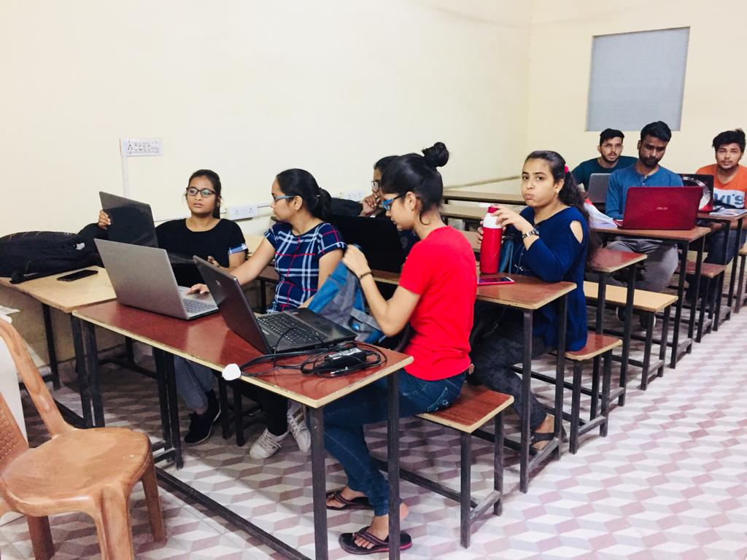

**Fig 2.5 Class Session**

**Chapter 3**

**Project Development**

* 1. **Introduction to Python**

Python is commonly used in [artificial intelligence](https://en.wikipedia.org/wiki/Artificial_intelligence) projects with the help of libraries like [tensorflow](https://en.wikipedia.org/wiki/TensorFlow), [Keras](https://en.wikipedia.org/wiki/Keras) and [Scikit-learn](https://en.wikipedia.org/wiki/Scikit-learn). As a scripting language with [modular architecture](https://en.wikipedia.org/wiki/Modular_programming), simple syntax and rich text processing tools, Python is often used for [natural language processing](https://en.wikipedia.org/wiki/Natural_language_processing).

Many operating systems include Python as a standard component. It ships with most [Linux distributions](https://en.wikipedia.org/wiki/Linux_distribution), [amigaos 4](https://en.wikipedia.org/wiki/AmigaOS_4), [freebsd](https://en.wikipedia.org/wiki/FreeBSD) (as a package), [netbsd](https://en.wikipedia.org/wiki/NetBSD), [openbsd](https://en.wikipedia.org/wiki/OpenBSD) (as a package) and [macos](https://en.wikipedia.org/wiki/MacOS) and can be used from the command line (terminal). Many Linux distributions use installers written in Python: [Ubuntu](https://en.wikipedia.org/wiki/Ubuntu_(operating_system)) uses the [Ubiquity](https://en.wikipedia.org/wiki/Ubiquity_(software)) installer, while [Red Hat Linux](https://en.wikipedia.org/wiki/Red_Hat_Linux) and [Fedora](https://en.wikipedia.org/wiki/Fedora_(operating_system)) use the [Anaconda](https://en.wikipedia.org/wiki/Anaconda_(installer)) installer. [Gentoo Linux](https://en.wikipedia.org/wiki/Gentoo_Linux) uses Python in its [package management system](https://en.wikipedia.org/wiki/Package_management_system), [Portage](https://en.wikipedia.org/wiki/Portage_(software)).

Python is used extensively in the [information security](https://en.wikipedia.org/wiki/Information_security) industry, including in exploit development.

* 1. **Introduction to project**

[Rajasthan](https://en.wikipedia.org/wiki/Rajasthan) is one of the most popular [tourist destinations](https://en.wikipedia.org/wiki/Tourist_destinations) in [India](https://en.wikipedia.org/wiki/India), for both domestic and international tourists. [Rajasthan](https://en.wikipedia.org/wiki/Rajasthan) attracts tourists for its historical forts, palaces, art and culture with its slogan 'Padharo mahare desh'. Every third foreign tourist visiting India travels to Rajasthan as it is part of the [Golden Triangle](https://en.wikipedia.org/wiki/Golden_Triangle_(India)) for tourists visiting India.[[1]](https://en.wikipedia.org/wiki/Tourism_in_Rajasthan#cite_note-1)[[2]](https://en.wikipedia.org/wiki/Tourism_in_Rajasthan#cite_note-2)

The palaces of [Jaipur](https://en.wikipedia.org/wiki/Jaipur), lakes of [Udaipur](https://en.wikipedia.org/wiki/Udaipur), and desert forts of [Jodhpur](https://en.wikipedia.org/wiki/Jodhpur), [Bikaner](https://en.wikipedia.org/wiki/Bikaner), and [Jaisalmer](https://en.wikipedia.org/wiki/Jaisalmer) are among the most preferred destinations of many tourists, Indian and foreign. Tourism accounts for eight percent of the state's domestic product. Many old and neglected palaces and forts have been converted into heritage hotels.

* + 1. **Purpose**
    2. **India one of the most beautiful locations of Rajasthan is also among the popular state of the world.**
    3. **Tourist hub welcomes more than a 5 thousands tourists from different locations of India.**
    4. **A trip to this beautiful state can reveal numerous mystic things regarding its culture, art, tradition, history etc.**
    5. **Tourists are more attracted towards the cultural of this state from Jaipur to Mount Abu. Each tradition symbolizes the flavour of the place.**
    6. **Rajasthan, a state with numerous scenic sports, Majestic forts is a tourist hub as well.**
    7. **Feasibility**
       1. **Time**

This project was aimed to be completed during the 2-month training period, along with gaining the knowledge about the core technology Python, this project has to be completed and planning is done according to training duration.

* + 1. **Functional Requirement / Non-Functional Requirement**
       1. **Functional Requirement**
          1. Signup
          2. Login
          3. Booking
          4. Logout
          5. Forgot Password
       2. **Non – Functional Requirement** 
          1. **Security**

Administrator has the highest authority to edit/delete/create database.

Password should be stored in encrypted form

* + - 1. **Technical Requirement**
         1. **Android OS Version:**  Lollipop or greater
         2. **RAM:** 1GB
         3. **Processor:** 1.4GHz ARM / Snapdragon / MTK
      2. **Communication Interfaces**
         1. **Internet:** Mobile should have internet connectivity for creating an account.
  1. **Roles & Responsibility**
     1. Understanding client requirement
     2. System analyst & system designer
     3. Coding & front end designer
     4. Testing & system maintenance
  2. **System Features**
     1. **Splash Screen:** Application starts with a splash screen having its logo.
     2. **User login screen:** To login or register to use the application.
     3. **Navigation Drawer:** This screen allows user to view the donor list who wants to donate blood and the drawer allows to view profile, edit profile, change password and logout options, and an option to communicate with the help centre, check the nearby hospitals and some blood facts.
  3. **Future Scope**

If we take this application forward then we have a future scope to add the location for nearby hospitals which are present in the hospitals API and we can also sort the donor list according to the requirement of blood group of a customer.

* 1. **Analysis Diagrams**

**3.5.1 Activity Diagram**

**Fig. 3.1 Activity Diagram**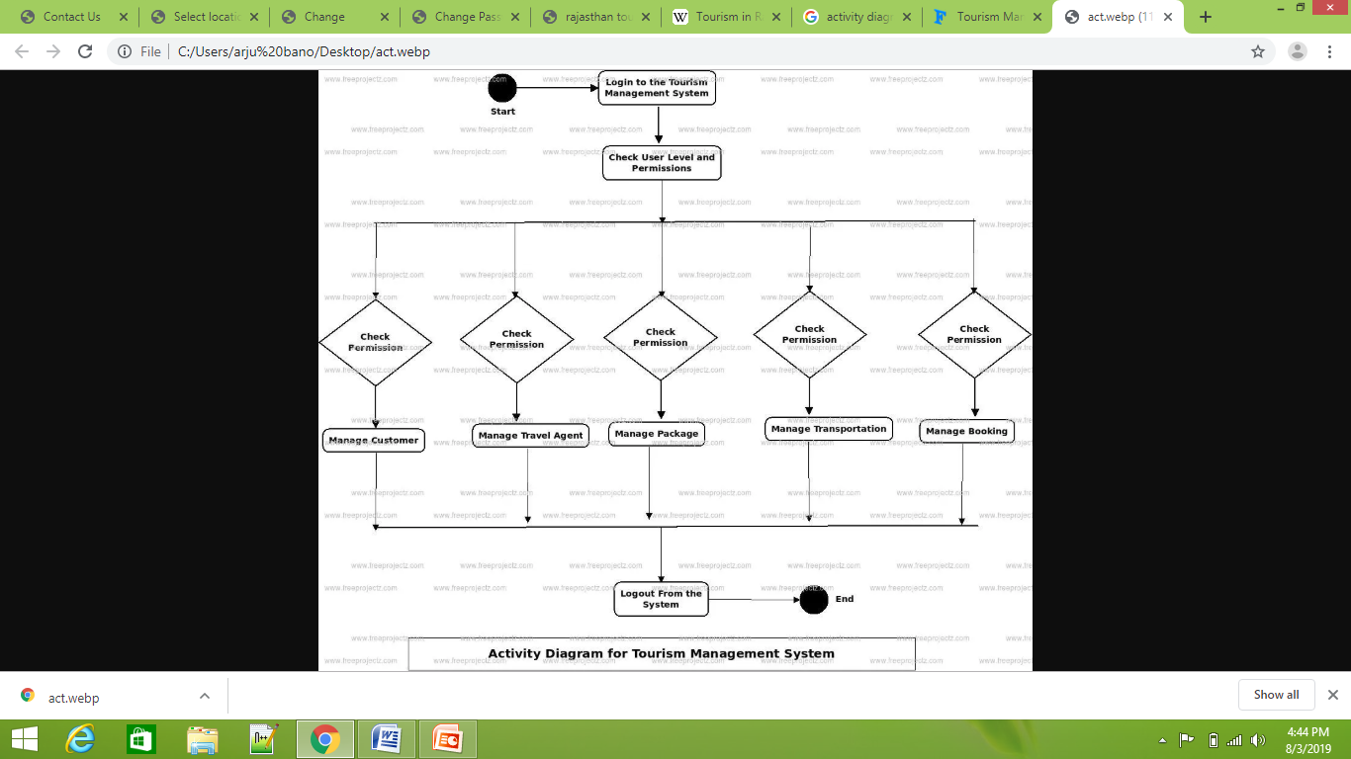

* 1. **System Implementation:**

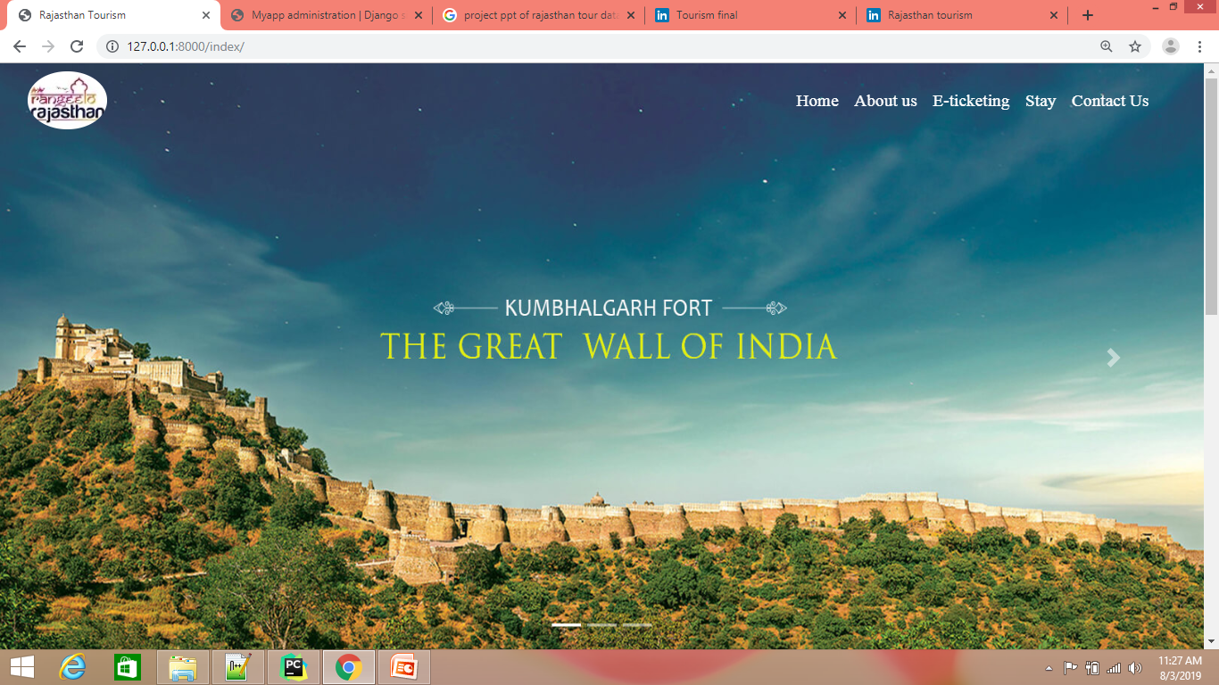

**Fig 3.1 Home Page**

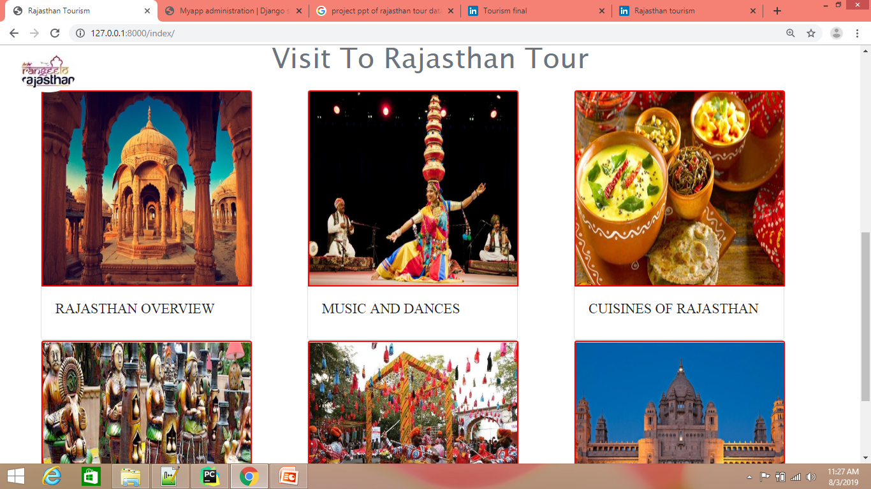

**Fig 3.2 Signup Modal**

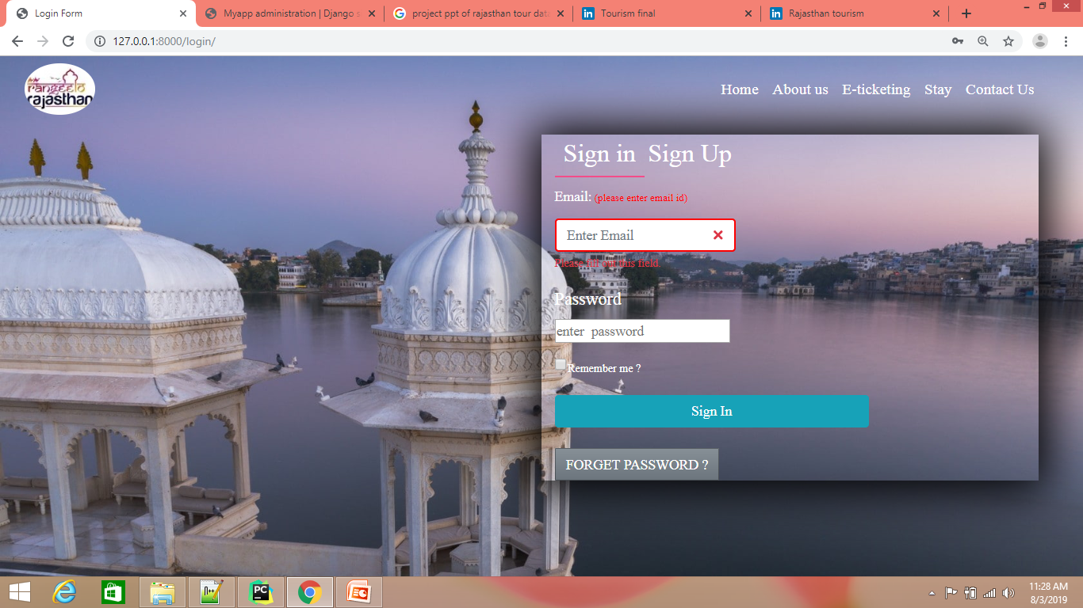

**Fig 3.3 LogIn Model:**

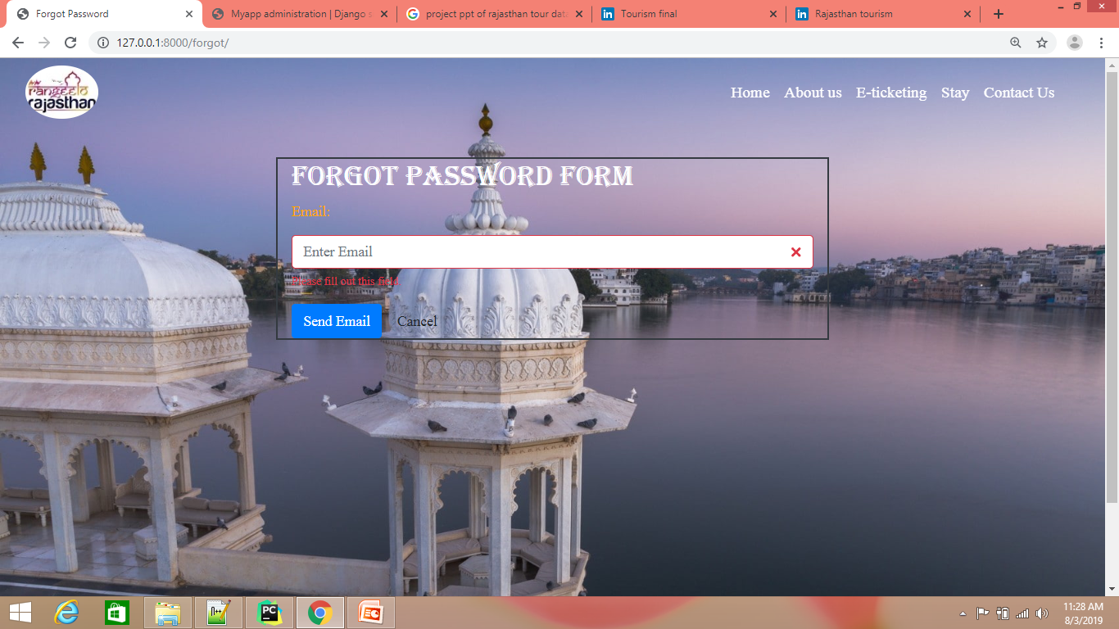

**Fig 3.4 Forgot Password**

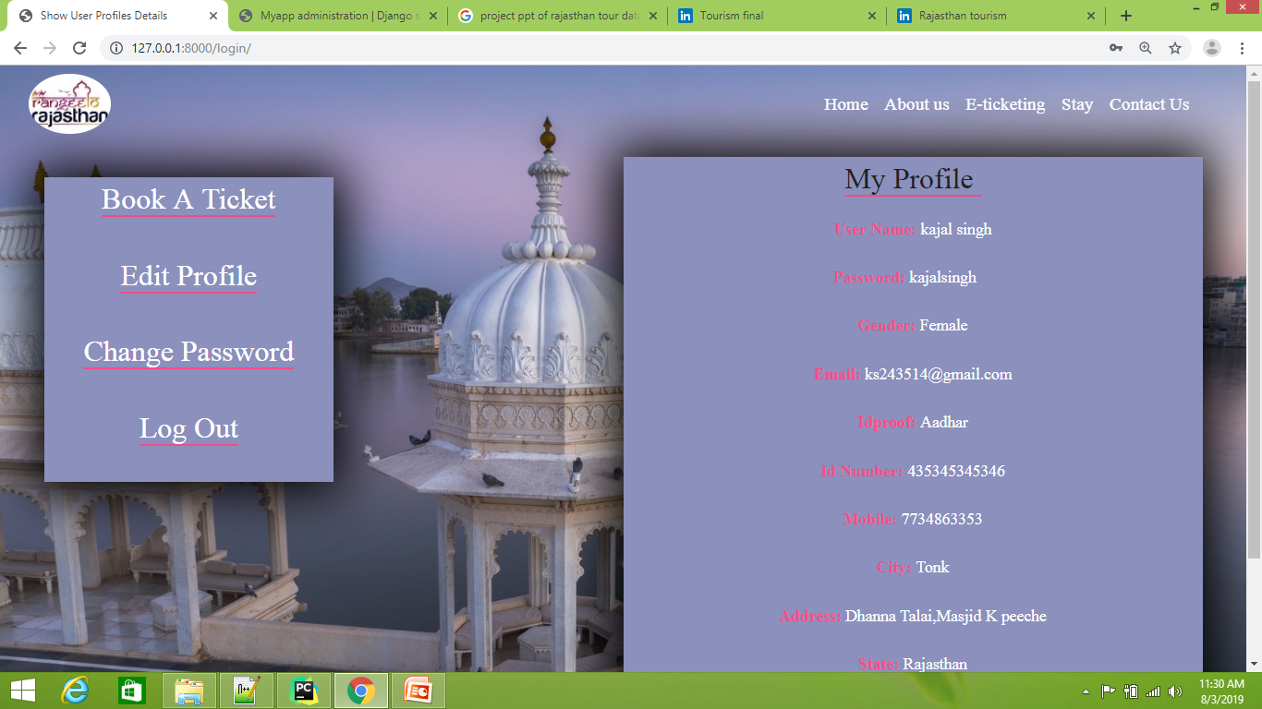

**Fig 3.5 My Profile**

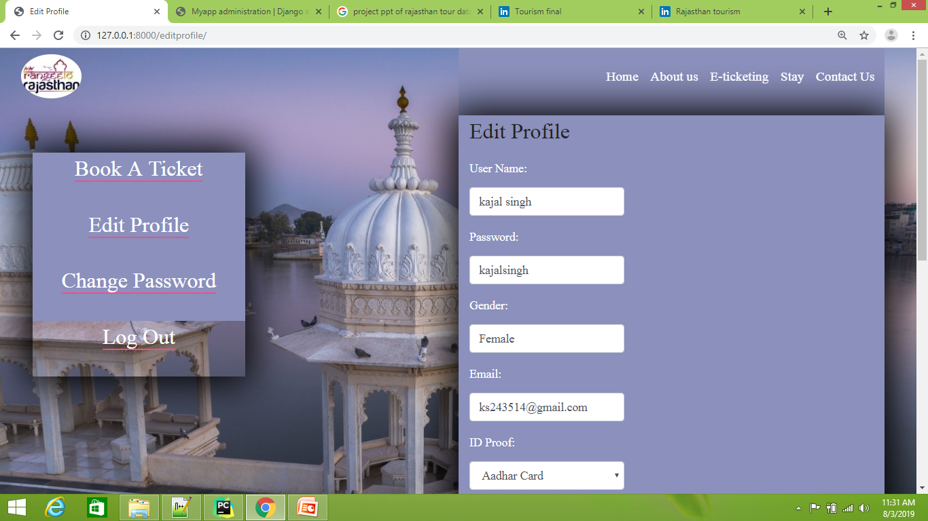

**Fig 3.6 Edit Profile**

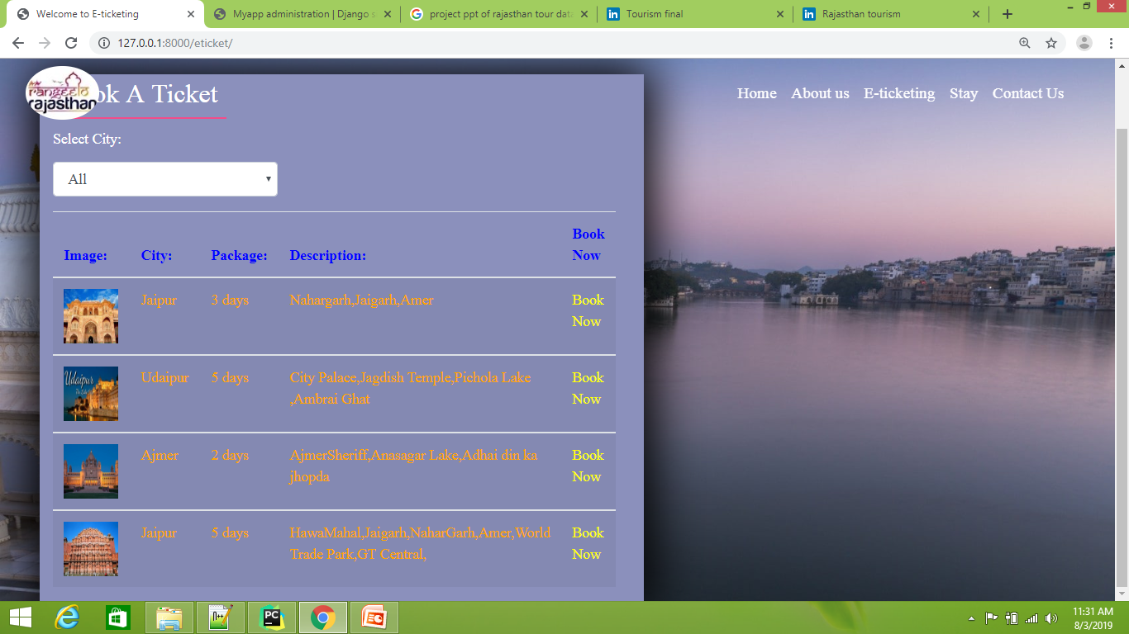

**Fig 3.7 Booking Pages**

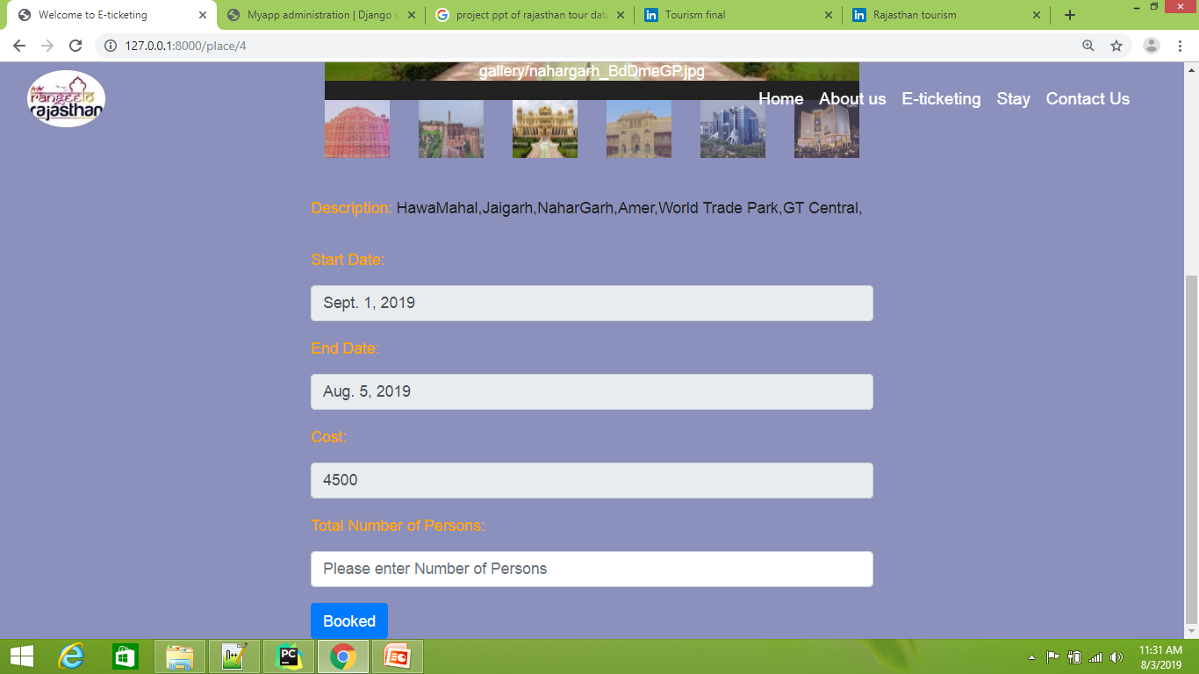

**Fig 3.8 Booking Details**

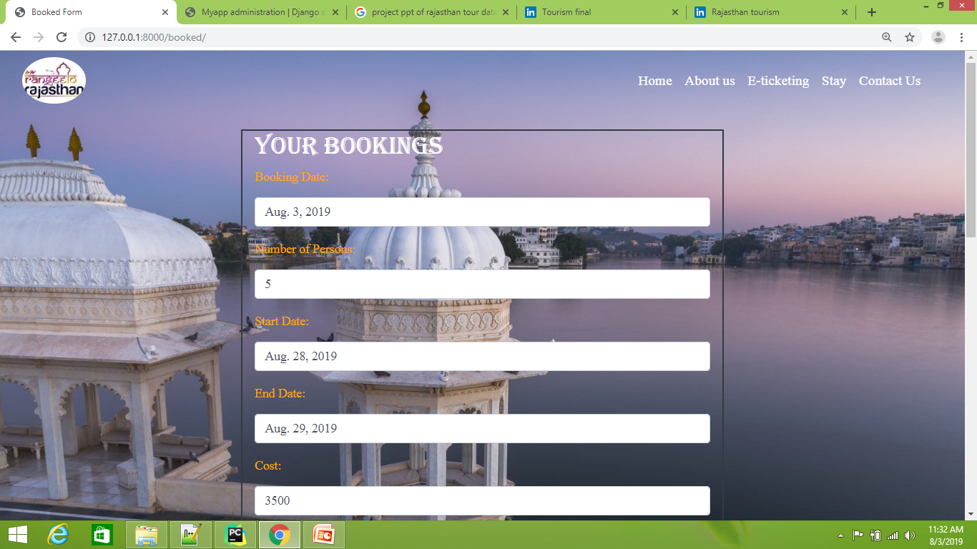

**Fig 3.9 Print Booking Details**

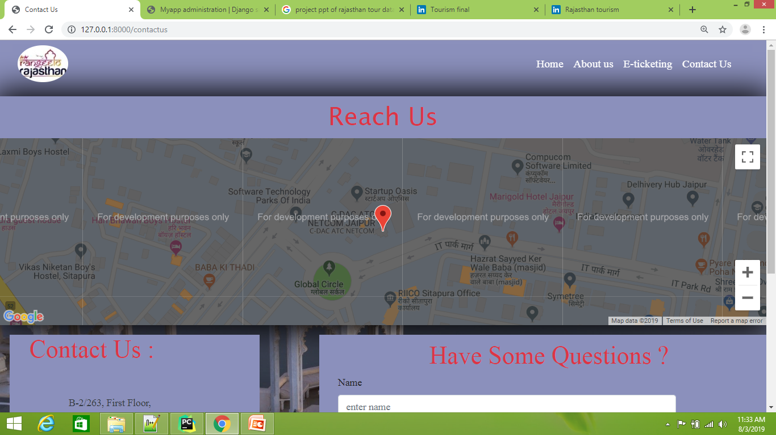

**Fig 3.10 Reach us**

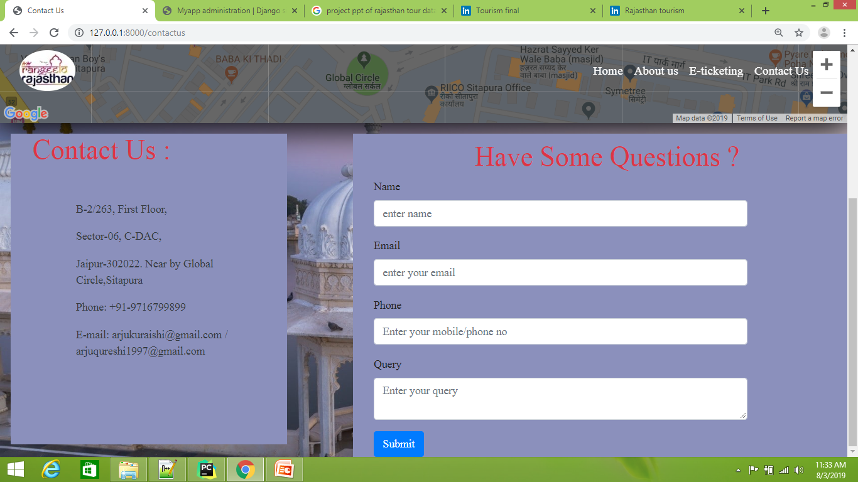

**Fig 3.11 Contact us & Query**

**Database**

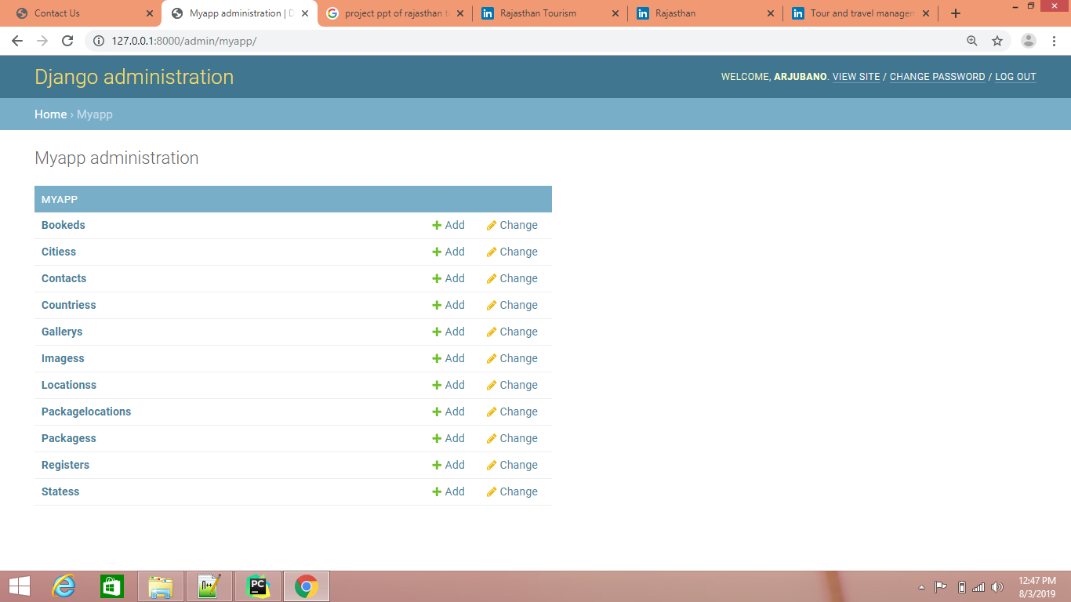

* 1. **System Testing**

The completion of a system is achieved only after it has been thoroughly tested. Though this gives a feel the project is completed, there cannot be any project without going through this stage. Hence in this stage it is decided whether the project can undergo the real time environment execution without any break downs.

* + 1. **Test Case 1**

Application was first tested with creating a user profile with special symbols but application didn’t allowed user to create a file with special symbols and error is shown to user.

* + 1. **Test Case 2**

Application is tested with donor list who checked the donation check box only.

* + 1. **Test Case 3**

Two similar ids cannot be generated

* + 1. **Test Case 4**

The calling option present in donor list is working and the contact us option with email and number is working.

* 1. **Conclusion**

The system analysis, system designing, coding, development, testing and implementation have been done.

**Chapter 4**

**Summary**

* 1. **Introduction**

This part of the report describes the overall result and various learning made during the training program and what all knowledge I gained from the training program.

* 1. **Lessons Learned / Skills Developed**
     1. **Technical**
* Android Application Development
* Working with Firebase
* Developing dynamic and static application
* XML
* Firebase Database
* Google APIs Integration
* Working with Google Play Console
  + 1. **Communication**
* Relationship with training staff
* Relationship with other trainees
* Sociability
  + 1. **Human**
* Team Work
* Leadership
* Learning ability
  1. **Exposure to Training Processes:**

During my training period, I pursued opportunities to learn android application development & java concepts. I learned introduction to Android, Firebase database, Android Studio, basic components of android interface, Firebase web & mobile application development.As a project I developed my training project “Blood Bank” & present this idea in front of the senior developers in CDAC.

* 1. **Knowledge Gained**

The training at CDAC ATC provided me an insight on Android Application Development the flourishing technology in market today and its recent trends in industry. Interaction with employees & great support from training coordinator enabled my successful completion of training. It provided industrial exposure and acted as a stepping stone for my career ahead.

* 1. **Limitations**

During the period of 60 days, the advanced topics in syllabus were skipped to lesser availability of time.

**References**

1. **Android Developer**

<https://developer.android.com/guide/index.html>

1. **Android Developer**

<https://developer.android.com/training/index.html>

1. **Tutorials Point**

<https://www.tutorialspoint.com/android/index.htm>

1. **Java T Point**

<https://www.javatpoint.com/android-tutorial>

1. **Google**

<https://www.google.co.in>